WPCP – Ms. Gallegos Spanish 3 Honors Suggested Summer Practice

Below you will find information on suggested summer practice activities to help keep your Spanish skills in shape over the summer! The first is a link to classroom sets of online flashcards on Quizlet.com. You should work on the sets called “Verbs you need to know” and “Essential Classroom Phrases”. It is essential you know these most common verbs and phrases in Spanish in order to be successful in Spanish 3. Your first homework grade of the semester and test will be on these verbs and phrases during the first weeks of school. If you struggled in level one, or just want some extra practice, I highly recommend taking a few minutes every week over the summer to get in some review and practice.

Quizlet Suggested Summer Practice Instructions
- Enroll in the Quizlet WPCP Spainsh 3 class here: https://quizlet.com/join/ufbVpKyNJ

- Please create a user name following this model:
  - lastnamefirstinitialwpcp (example: gallegoskwpcp)

- You are expected to have completed all the activities in their entirety for both sets within the first weeks of school. These include: Flashcards, Learn, Speller, Test, Scatter and SpaceRace.

- Please make sure you are logged in under your username while completing your work or your progress will not be recorded.

- There is a Quizlet app for Android and Iphones, which I highly recommend! Note: not all of the practice activities are available on the app so you will need to do some of the work from a computer.

- Link to Verbs You Should Know: https://quizlet.com/_1ecyr7

- Link to Essential Classroom Phrases: https://quizlet.com/_1ed0aa

Additional Practice
In the document that follows you will find additional helpful resources for summer study, including online grammar practice. You may also want to visit my Spanish 3 website at http://gallegoscentral.pbworks.com/. I encourage you to utilize these resources over the summer for a successful transition into Spanish 3. ¡Gracias! And I look forward to seeing you en septiembre!
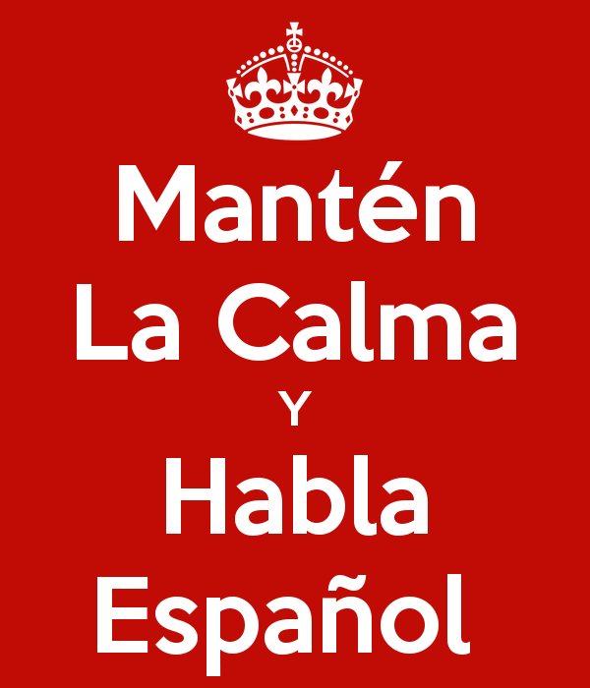

Srta. Gallegos
Spanish Teacher, Global Connections Chair

Ms. Gallegos’s Class Website: http://gallegoscentral.pbworks.com/

*Global Connections @ WPCP: http://paytonglobetrotters.weebly.com/
* If you missed the chance to broaden your horizons through global travel and exchange experiences this year, mark your calendar now to plan for next year. Key deadlines and info sessions on travel opportunities come up very quickly in the fall, so start thinking now about places you'd like to travel and courses of study you'd like to undertake. Always check the program websites and Payton Global Connections for specific due dates and guidelines.
Additional Summer Practice Resources

DuoLingo: https://www.duolingo.com/
Learning with Duolingo is fun and addictive. Earn points for correct answers, race against the clock, and level up. It is a great way to brush up on your Spanish skills and to challenge yourself further. All WPCP Spanish students will be asked to register for Duolingo at the start of the school year, but we recommend you get a head start. Please use the same username format as you did for Quizlet of lastname.firstinitial.wpcp (example: gallegos.k.wpcp)

LINKS TO ONLINE GRAMMAR GAMES
Below are links to practice activities for different grammar concepts that you so should be familiar with before starting class next year.

For students entering Spanish 2 and up

Pronombres de objeto http://www.quia.com/pop/10718.html?AP_rand=1278745312
Pronombres de objeto http://www.quia.com/jg/89820.html
Pronombres de objeto http://www.colby.edu/~bknelson/SLC/DO_or_IO.php
Pronombres de objeto http://www.colby.edu/~bknelson/SLC/DO_IO_3.php
Pronombres de objeto http://www.colby.edu/~bknelson/SLC/DO_IO_1.php

Presente, regular
http://www.elma.wednet.edu/cms/lib2/WA01001699/Centricity/domain/112/elmaeagles/elmaeagl/web/gameobjects/sv1.html
Presente, "yo" irregular http://www.elma.wednet.edu/cms/lib2/WA01001699/Centricity/domain/112/elmaeagles/elmaeagl/web/gameobjects/sv2.html
Presente, regular e irregular - Burrito Builder! http://www.spanishprograms.com/spanish_teacher/learning_module/games.php
Presente, stem-changers http://www.elma.wednet.edu/cms/lib2/WA01001699/Centricity/domain/112/elmaeagles/elmaeagl/web/gameobjects/sv3.html

Gustar and verbs like it http://www.quia.com/rr/92306.html
Gustar and verbs like it http://www.quia.com/pop/10717.html?AP_rand=1507323140
Gustar and verbs like it http://www.studyspanish.com/lessons/games/gustar-sp.htm
Gustar and verbs like it http://www.colby.edu/~bknelson/SLC/gustar1.php

Ser versus Estar http://www.quia.com/quiz/438253.html
Ser versus Estar http://www.quia.com/mc/400520.html
Ser versus Estar http://www.quia.com/cc/400520.html
Ser versus Estar http://www.purposegames.com/game/9f4978b3d4
Ser versus Estar http://atschool.eduweb.co.uk/rgshiwyc/school/curric/Spanish/SerEstar/10.htm
Ser versus Estar http://www.superteachertools.com/jeopardy/usergames/Apr201014/game1270475619.php
Ser versus Estar http://www.colby.edu/~bknelson/SLC/ser_estar.php

Pretérito, regular verbs http://www.quia.com/pa/92861.html
Pretérito, -ar verbs http://www.quia.com/jg/1507954.html
Pretérito, stem-changers (i-y) http://quizlet.com/5786779/spanish-3-i-to-y-stem-changing-verbs-in-the-preterite-flash-cards/
Pretérito, stem-changers (e-i, o-u) http://quizlet.com/4462047/preterite-stem-changerse-i-o-u-flash-cards/
Pretérito, stem-changers http://www.proprofs.com/quiz-school/story.php?title=spanish-verb-quiz-14-preterite-stemchanging-verbs
Pretérito, stem-changers http://www.colby.edu/~bknelson/SLC/pret3_ortho.php
Pretérito, stem-changers http://www.quia.com/quiz/1402039.html?AP_rand=1047957048
Pretérito, -car, -gar, -zar http://www.spanishdict.com/topics/practice/61
Pretérito, regular verbs and -car, -gar, -zar http://www.quia.com/rr/226637.html
Pretérito, -car, -gar, -zar and other stem-changers (click NEXT at top to scroll through games) http://www.mentormob.com/learn/i/spanish-preterite-complete-review/scattering-spanish-2-cargar-zar-verbs-quizlet
Pretérito, 9 different games http://reviewgamezone.com/game.php?id=323
Pretértio, irregular http://www.sporcle.com/games/asebi/spanish-irregular-preterite-verbs
Preterite Matching Game http://www.purposegames.com/game/spanish-preterite-verbs-3-quiz
Pretértio, regular http://www.elma.wednet.edu/cms/lib2/WA01001699/Centricity/domain/112/elmaeagles/elmaeagl/web/gameobjects/sv4.html
Pretérito, regular http://www.learnspanishtoday.com/learning_module/burrbuild.htm?n=preteriteTenseAr.xml&t=AR%20Past%20Tense
Pretérito, irregular http://www.elma.wednet.edu/cms/lib2/WA01001699/Centricity/domain/112/elmaeagles/elmaeagl/web/gameobjects/sv5.html
Pretérito, regular e irregular, dar, ir/ser, ver http://www.quia.com/cb/347758.html

For students entering Spanish 3 and up (plus all of the above)

Pretérito versus Imperfecto (explanation only) http://www.drlemon.com/Grammar/pretvsimp.html
Pretérito versus Imperfecto http://www.quia.com/quiz/157080.html?AP_rand=1099798776
Pretérito versus Imperfecto http://www.studyspanish.com/practice/pretimp2.htm
Pretérito versus Imperfecto http://www.studyspanish.com/practice/pretimp4.htm
Pretérito versus Imperfecto http://www.studyspanish.com/practice/pretimp1.htm
Pretérito versus Imperfecto http://www.quia.com/pop/3356.html
Pretérito versus Imperfecto http://www.trinity.edu/mstroud/grammar/pret4.htm
Pretérito versus Imperfecto http://www.bowdoin.edu/~eyepes/newgr/pretimp2.htm
Pretérito versus Imperfecto http://www.colby.edu/~bknelson/SLC/ricitos1.php
Pretérito versus Imperfecto http://www.colby.edu/~bknelson/SLC/quemiedopase.php
Pretérito versus Imperfecto http://www.colby.edu/~bknelson/SLC/superhombre2.php
Imperfecto http://www.elmaeagles.com/gameobjects/sv6.html

Tú commands http://www.elma.wednet.edu/cms/lib2/WA01001699/Centricity/domain/112/elmaeagles/elmaeagl/web/gameobjects/sv8.html
Tú commands http://www.quia.com/jg/293778.html (skip the Word Search game)
Tú commands http://www.quia.com/jg/67102.html
Tú commands http://www.quia.com/cb/274077.html
Tú commands http://www.trinity.edu/mstroud/grammar/commands.htm
Tú commands http://www.quia.com/quiz/2490606.html

All other commands http://www.elmaeagles.com/gameobjects/sv9.html

Por versus para (youtube rap video/song) https://www.youtube.com/watch?v=fd0dlBZEw18
Por versus para http://www.quia.com/cz/46479.html?AP_rand=1873003309
Por versus para http://www.spanishnewyork.com/automatic/porpara.php
Por versus para http://www.colby.edu/~bknelson/SLC/por_para.php
Por versus para http://www.quia.com/cb/53051.html

"Se" with accidental or unplanned events (explanation only) http://www.elearnspanishlanguage.com/grammar/verb/accidentalreflexive.html
"Se" with accidental or unplanned events http://www.colby.edu/~bknelson/SLC/unplanned_se.php

Subjuntivo, presente (repaso de los usos) http://www.quia.com/cz/90397.html?AP_rand=1283491500
Subjuntivo, regulares http://www.quia.com/quiz/1561516.html?AP_rand=800896848
Subjuntivo, presente (conjugaciones) http://www.elmaeagles.com/gameobjects/sv10.html
Subjuntivo, presente (formación) http://www.quia.com/rr/92637.html
Subjuntivo, presente (formación y usos) http://www.quia.com/rr/92946.html
Subjuntivo, presente (spell-changing) http://www.quia.com/quiz/452307.html?AP_rand=1333066879
Subjuntivo, presente (aconsejar + subj.) http://www.spanish.cl/Grammar/Games/Aconsejar_Que_Subjuntivo.htm

